**Project Report**

**Comprehensive Analysis of Petrol vs Electric Scooters in India**

**Index**

1. *Description*
2. *Plan*
3. *Design (Diagrams)*
4. *Implementation*
5. *Code Explanation*
6. *Output Screenshots*
7. *Closure*
8. *Bibliography*

**Description**

**Problem Statement**

*The transition from petrol-powered scooters to electric scooters is gaining momentum in India due to environmental concerns, government incentives, and technological advancements. However, consumers and stakeholders need a comprehensive comparison of petrol and electric scooters to make informed decisions***.**

**Objective**

*This project aims to analyze and compare petrol and electric scooters across multiple dimensions:*

* *Market trends and growth projections*
* *Total cost of ownership*
* *Environmental impact*
* *Performance and technology*
* *Infrastructure and ecosystem*
* *Consumer behavior and adoption*
* *Manufacturer ecosystem*
* *Future outlook*

**Data Sources**

*The analysis uses four Excel files:*

1. *scooter_sales_data.xlsx – Petrol scooter sales data.*
2. *India_Electric_2Wheeler_Sales.xlsx – Electric scooter sales data.*
3. *EV_Battery_Analysis.xlsx – Battery cost and lifespan data.*
4. *Top_25_E2W_Manufacturers_FY2025.xlsx – Top electric scooter manufacturers.*

**Outcome & Benefits**

* *Helps consumers choose between petrol and electric scooters based on cost, performance, and environmental impact.*
* *Assists manufacturers in understanding market trends and consumer preferences.*
* *Provides policymakers insights into infrastructure needs and incentives.*

**Plan**

*The analysis is structured into nine sections:*

1. ***Market Overview & Trends****– Sales, market share, growth rates, and projections.*
2. ***Total Cost of Ownership****– Fuel, maintenance, insurance, and battery costs.*
3. ***Environmental Impact****– CO2 emissions, energy consumption, and noise pollution.*
4. ***Performance & Technology****– Speed, acceleration, efficiency, and smart features.*
5. ***Infrastructure & Ecosystem****– Charging stations, service centers, and government incentives.*
6. ***Consumer Behaviour & Adoption****– Preference factors and adoption barriers.*
7. ***Manufacturer Ecosystem****– Market concentration and top players.*
8. ***Future Outlook & Predictions****– Technology roadmap and market evolution.*
9. ***Executive Summary****– Key findings and recommendations.*

**Implementation**

***Tools & Libraries Used***

* ***Python****(Pandas, Matplotlib, Seaborn, NumPy)*
* ***Jupyter Notebook / IDE****for execution.*

***Steps***

1. ***Data Loading & Validation***
   * *Check for missing files.*
   * *Read Excel files into DataFrames.*
2. ***Market Analysis***
   * *Calculate total sales, market share, and growth rates.*
   * *Plot sales trends and projections.*
3. ***Cost Analysis***
   * *Compute fuel, maintenance, and battery costs over 10 years.*
   * *Visualize cumulative costs.*
4. ***Environmental Impact***
   * *Compare CO2 emissions, energy use, and noise levels.*
5. ***Performance & Tech***
   * *Compare speed, acceleration, and smart features.*
6. ***Infrastructure & Policy***
   * *Analyze charging stations and government incentives.*
7. ***Consumer & Manufacturer Insights***
   * *Evaluate adoption barriers and market concentration.*
8. ***Future Predictions***
   * *Forecast market share and technology advancements.*
9. ***Executive Summary***
   * *Summarize key insights and recommendations.*

**Output Screenshots**

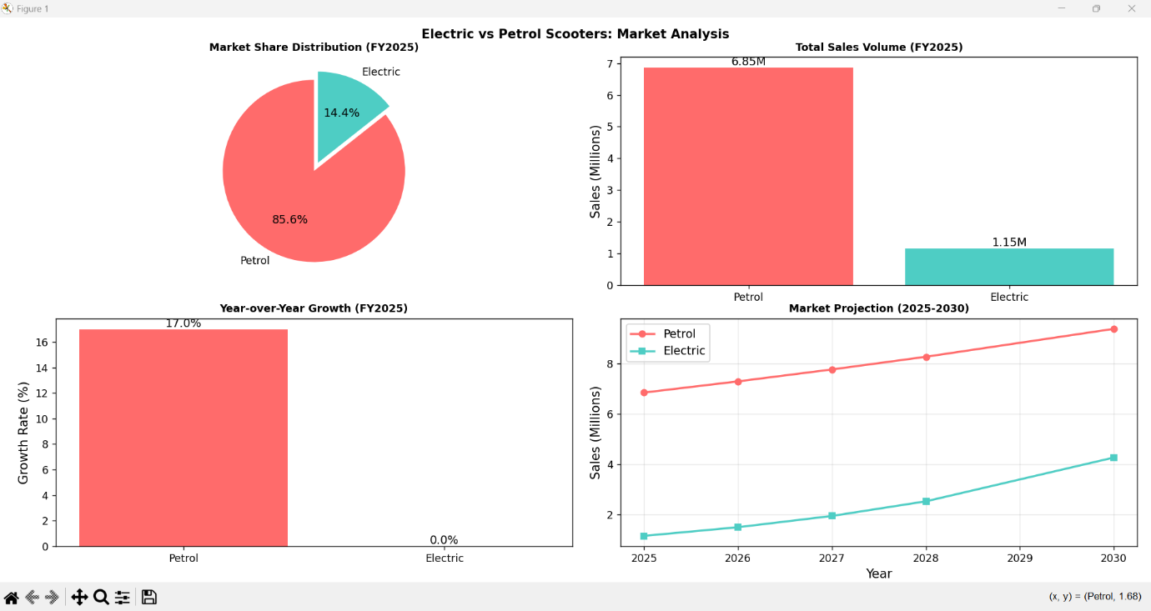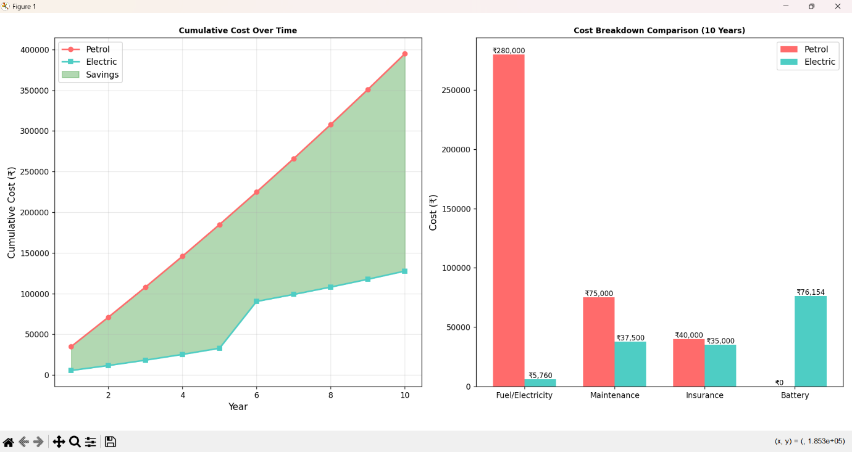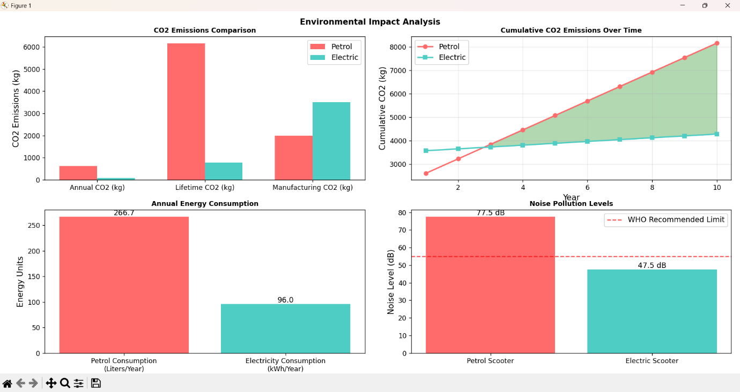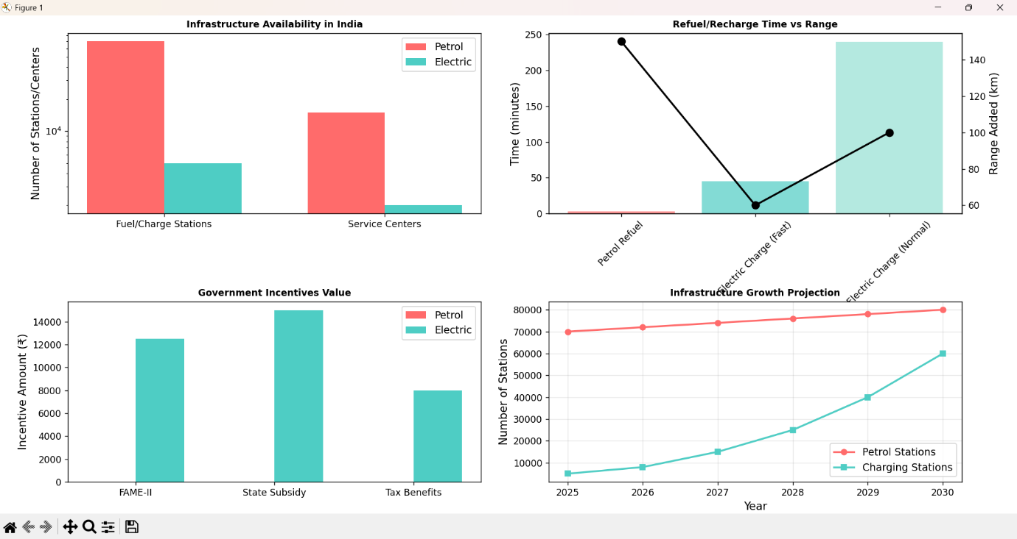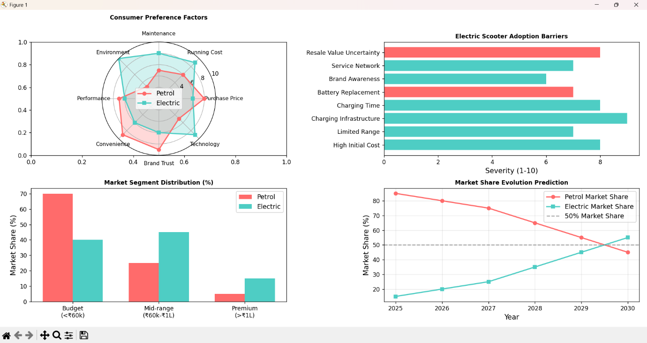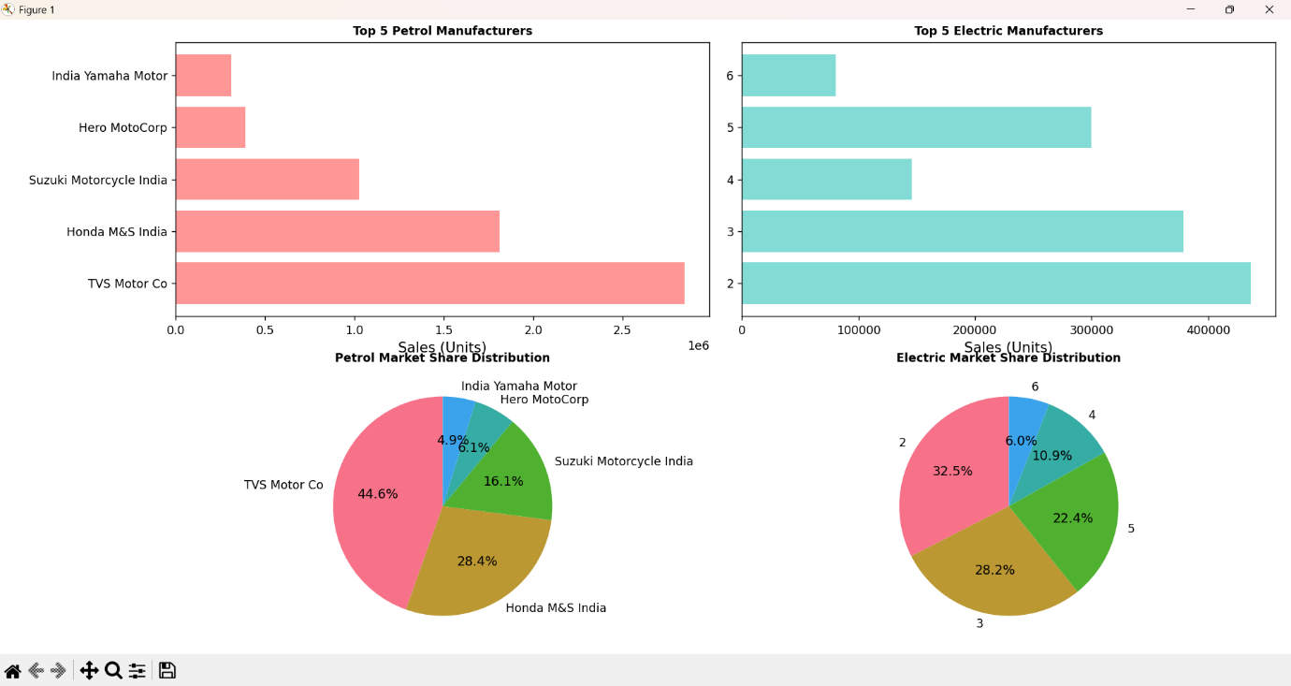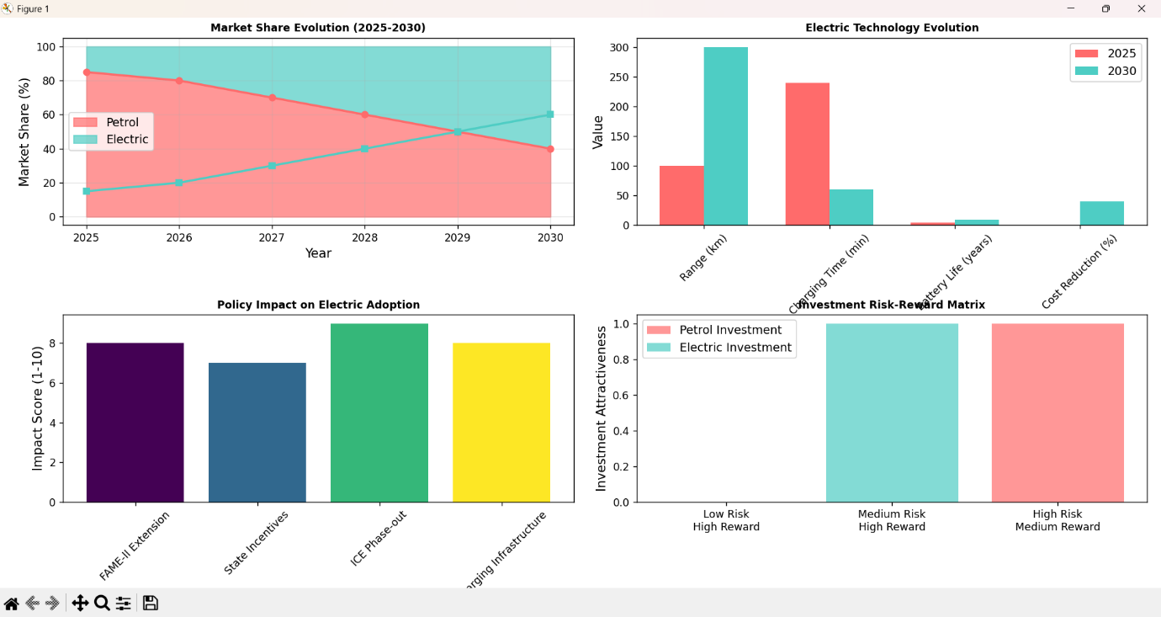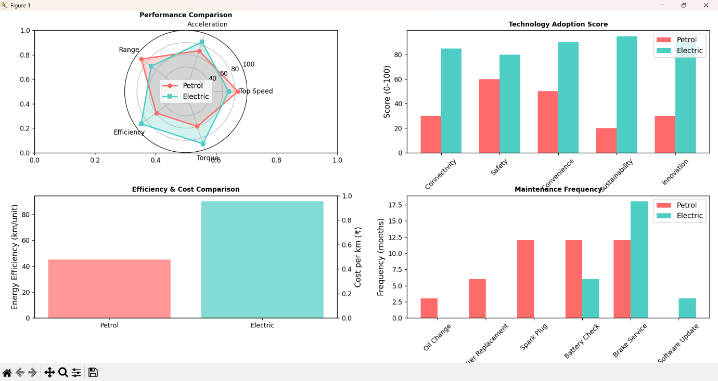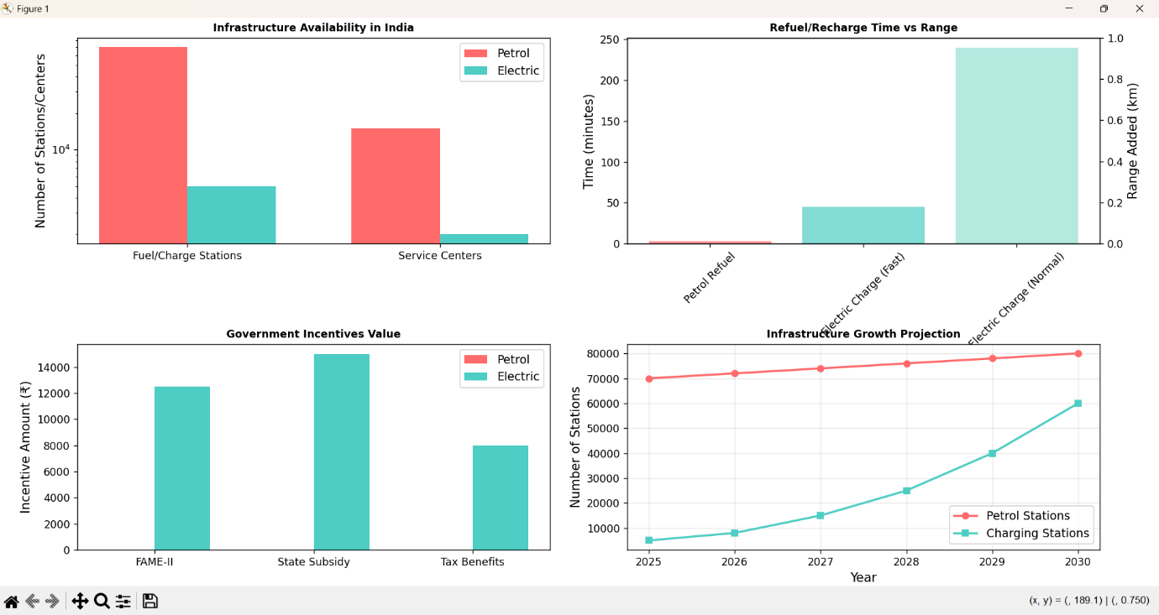

**Closure**

***Findings***

* ***Electric scooters****are cheaper in the long run (₹1.5L savings over 10 years).*
* ***Petrol scooters****dominate market share (85%) but growth is slowing.*
* ***CO2 savings****with electric: ~5,000 kg over 10 years.*
* ***Adoption barriers****: High upfront cost and charging infrastructure.*

***Recommendations***

* ***Consumers****: Choose electric for city commutes (<100 km/day).*
* ***Manufacturers****: Invest in battery tech and fast-charging solutions.*
* ***Policymakers****: Expand charging infrastructure and extend subsidies.*

**Bibliography**

* ***Government Reports****: FAME-II policy, NITI Aayog EV roadmap.*
* ***Industry Data****: SIAM (Society of Indian Automobile Manufacturers),*

*Autocar Professionals articles.*

* ***Technical References****: Battery lifespan studies, CO2 emission factors.*